**Nishay Madhani (00212195)**

**Program Structures & Algorithms**

**Fall 2021**

**Assignment No. 3**

## 1. **Tasks Performed**

1. Implemented the *UF_HWQUPC.java* Class with Size-Weighted Quick Union with path compression and ran the unit tests provided.
2. Added a *Assignment3.java* to src/…./assignments, with a main and count.
3. Plotted results from count to a graph using *JFreeChart*

## 

## **2. Conclusion:**

$m = 0.5 * N * lg N, m = number of connections, N= no of sites$

## **3. Relationship**

| **N** | **M** | **N log N** | **0.5 N log N** |
| --- | --- | --- | --- |
| ***100*** | ***252*** | **460** | ***230*** |
| **200** | **572** | **1060** | **530** |
| **400** | **1216** | **2400** | **1200** |
| **800** | **2543** | **5400** | **2700** |
| **1600** | **6379** | **11800** | **5900** |

## **4. Evidence**

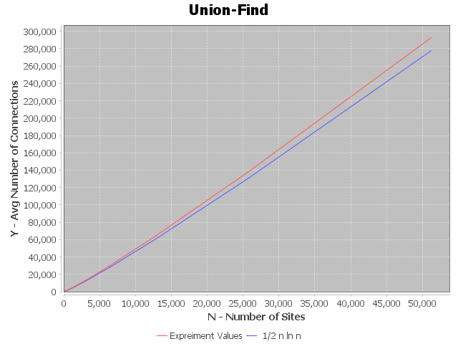

## 

## **5. Unit Tests and Output**

***Assignment3.java***

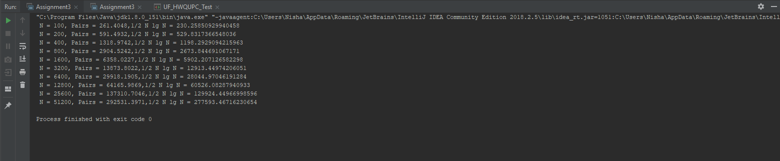

***UF_HWQUPC.java***

## 